MACHINE LEARNING PROJECT PLAN

Heart Disease Prediction Using Python
A five-week plan from project idea to tested model
Internship task
Virtual Machine Learning Assistant Intern | Week 1: Project Planning and Strategy
Project window: 20 October 2026 – 24 November 2026 | Duration: 5 weeks

Document control | Details
Prepared for | Virtual Machine Learning Assistant Internship
Project type | Two-class prediction using supervised learning
Primary language | Python
How the model may be used | For learning and research only; not a medical diagnosis tool
Version | 1.0 | 22 October 2026

1. Executive Summary
This project will build and test a Python model that predicts whether a patient record shows signs of heart disease. The main users are students, data teams, and healthcare research teams. The model is for learning and research. It must not replace a doctor, a medical exam, or an approved clinical risk score.
The work will be done in stages: define the target, check and prepare the data, build two basic models, test their results, and document what we learn. Success is not just high accuracy. The project must also find most positive cases, show useful ROC-AUC, explain errors, use repeatable data preparation, and state its limits clearly.

What success looks like
- A Python workflow that can be run again and gives the same type of predictions.
- A simple logistic-regression model and a random-forest model for comparison.
- A test report with accuracy, precision, recall, F1, ROC-AUC, and confusion matrices.
- A data dictionary, risk list, model summary, and handoff checklist.
- A prototype that needs more testing. It is not a diagnosis or treatment recommendation.

2. Introduction and Background

2.1 The problem
Heart-disease data can include age, symptoms, exam results, and lab results. A supervised learning model can learn patterns that separate records with disease from records without disease. The goal is to build a model that is useful for study, easy to check, and careful about missed positive cases.

2.2 Who will use it and why
User group | Need | Planned value
Clinical analytics / research team | A repeatable test for comparing inputs and models. | Clear scores, charts, and a record of each test.
Data-science learner | A complete example of an ML project in Python. | A simple plan from loading data to writing the model summary.
Healthcare stakeholder | A clear view of what the model does well and where it makes mistakes. | Simple summary with no unsupported medical claims.

2.3 Dataset and target
This plan uses the Cleveland part of the UCI Heart Disease dataset. It has 303 records and 13 input fields, including age, sex, chest-pain type, blood pressure, cholesterol, maximum heart rate, and exercise-related chest pain. In the original data, 0 means no disease and 1–4 mean different levels of disease. Here, the target is simplified to 0 = no disease and 1 = disease present [1]. Missing values are shown as “?” and will be filled with the middle value in the model workflow.
Data and ethics
This dataset is small and old. It may not represent today’s patients, local healthcare settings, or any specific group. This planning document does not use personal names or other identifying information.

3. Project Goals and Objectives

3.1 Short-term goals (Weeks 1–3)
- Define the problem as a two-class prediction task and write down the target and success rules.
- Create a list of fields, a data-quality checklist, and a repeatable train/test split.
- Build a clear logistic-regression baseline and compare it with a random forest.
- Create first scores and charts, and pay special attention to missed positive cases.
- Write down assumptions, how missing data is handled, how data leaks are prevented, and the settings used.

3.2 Long-term goals (Weeks 4–5 and later)
- Check whether the predicted probabilities are reliable and choose a cutoff with stakeholder input.
- Check model results and fairness across available demographic groups.
- Test the model on a different, newer, or local dataset.
- Turn the workflow into a small API or dashboard only after formal approval.
- After any approved release, watch for data changes, data errors, poor probability scores, and changes in results.

3.3 Success rules
Area | Proposed target / acceptance rule
Repeatability | Another user can follow the steps and get nearly the same results.
Model separation | ROC-AUC ≥ 0.75 on the saved test set is a planning goal, not a medical claim.
Finding positive cases | Recall ≥ 0.80 is preferred because missed positive cases must be reviewed.
Easy to understand | The model summary includes feature effects, the confusion matrix, the cutoff, and the limits of the model.
Data quality | There are no unexplained missing-value errors, data leaks, or hidden data-preparation steps.

4. Scope, Assumptions, and Limits

In scope
- Binary classification prototype in Python.
- Data checks, data preparation, model training, testing, score reporting, and charts.
- Comparison of a simple, easy-to-explain model and a tree-based model.
- Technical notes, a risk list, and a recommendation for the next step.

Out of scope
- Medical diagnosis, treatment advice, or automatic patient sorting.
- Connection to a patient record system or patient-facing tool.
- Proof that a factor causes heart disease.
- Claims that the results apply to all other patient groups.

Key constraints
- The small dataset (303 records) makes the results less certain.
- The original label is old and is not the same as a current medical diagnosis.
- Some fields use codes and need clear explanations.
- Changing the cutoff changes the number of missed cases and false alarms.
- Healthcare data needs privacy, security, formal review, and responsible-AI checks before use.

5. Project Steps and Timeline
The project is split into five stages. Each stage produces work for the next one. The plan assumes about 8–12 focused hours each week, plus time to review the work.
Week / dates | Stage and goal | Main actions | Needs / result
Week 1  20–26 Oct | Plan and frame the problem | Define the target; list users; write success scores; inspect the data; and list risks and approval limits. | None. Output: approved project brief, data contract, risk register.
Week 2  27 Oct–2 Nov | Prepare and understand the data | Load the data; check missing values and distributions; create the target; split the data; prepare it safely; and make profile charts. | Week 1. Output: analysis-ready dataset and EDA notebook.
Week 3  3–9 Nov | Build baseline models | Train logistic regression and random forest; use the same random seed; save the settings; and create predictions and probabilities. | Week 2. Output: versioned baseline models and experiment log.
Week 4  10–16 Nov | Evaluate and explain | Calculate scores; review confusion matrices and ROC curves; compare cutoffs; check important features; and write down limits and group results. | Week 3. Output: evaluation report and model card draft.
Week 5  17–24 Nov | Handoff and next-step decision | Run everything again in a clean environment; package the code and requirements; finish the report; get peer feedback; and decide whether to stop, improve, or seek outside testing. | Weeks 1–4. Output: final project package, presentation-ready summary, go/no-go recommendation.

5.1 Action checklist
- Create separate folders for raw data, notebooks or scripts, charts, reports, and model files.
- Record where the data came from, when it was downloaded, the field names, missing-value rules, and target changes.
- Study the data before training models. Do not use the test set to choose data-preparation steps or cutoffs.
- Use a balanced split and keep filling missing values and scaling inside the model workflow.
- Train logistic regression first, then compare a random forest using the same test method.
- Report class balance, confusion matrices, accuracy, precision, recall, F1, ROC-AUC, and how scores change across validation runs.
- Review missed positive cases and false alarms, then explain the practical cost of each type of mistake.
- Create a model summary with its purpose, data, scores, limits, ethical points, and monitoring needs.
- Package the final notebook or script with a README and a test showing that it runs in a clean environment.
- Get approval before connecting the model to real healthcare data or workflows.

6. Scores and Example Results
For this example, 80% of the data is used for training and 20% is kept for testing. The split is balanced and uses random seed 42. The scores below come from the real Cleveland subset. They show how the project will be tested; they do not show that the model is ready for medical use.
Model | Accuracy | Precision | Recall / sensitivity | F1 | ROC-AUC
Logistic regression | 0.869 | 0.812 | 0.929 | 0.867 | 0.950
Random forest | 0.885 | 0.839 | 0.929 | 0.881 | 0.963

How to read the scores: recall shows how many disease-positive records were found. Precision shows how many positive predictions were correct. ROC-AUC shows how well the model ranks cases across different cutoffs. Because the dataset is small, one split may change the results. The final analysis should use confidence intervals or repeated testing when possible.
Model | 5-fold mean accuracy | 5-fold mean precision | 5-fold mean recall | 5-fold mean F1 | 5-fold mean ROC-AUC
Logistic regression | 0.825 | 0.819 | 0.798 | 0.807 | 0.911
Random forest | 0.842 | 0.854 | 0.791 | 0.820 | 0.910

7. Charts

7.1 Data overview
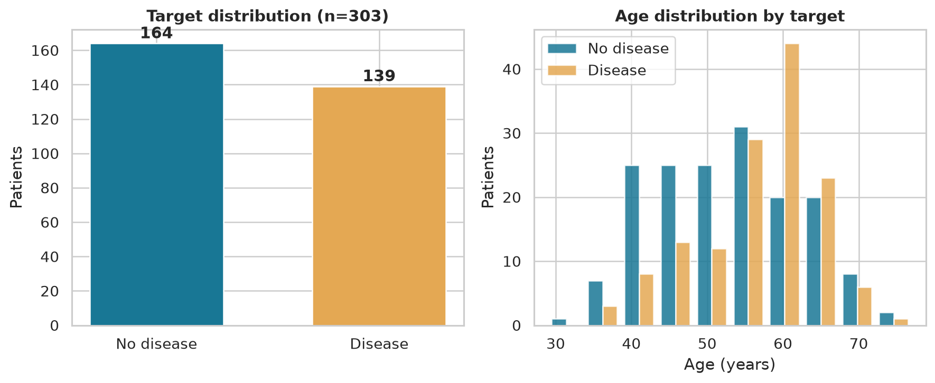
Figure 1. There are somewhat more disease-positive records. The age ranges overlap, so age alone is not enough to make a decision.

7.2 ROC comparison
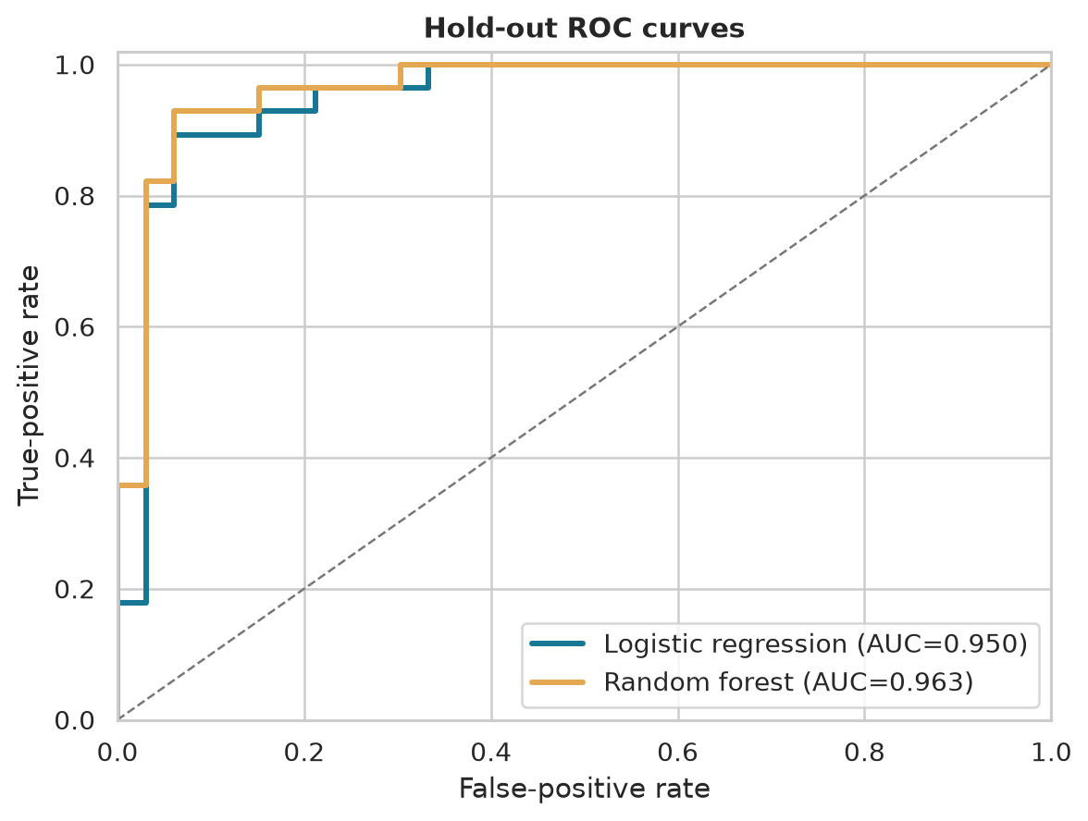
Figure 2. These ROC curves compare the models at different cutoffs. The cutoff should be chosen with stakeholders instead of automatically using 0.50.

7.3 Error review
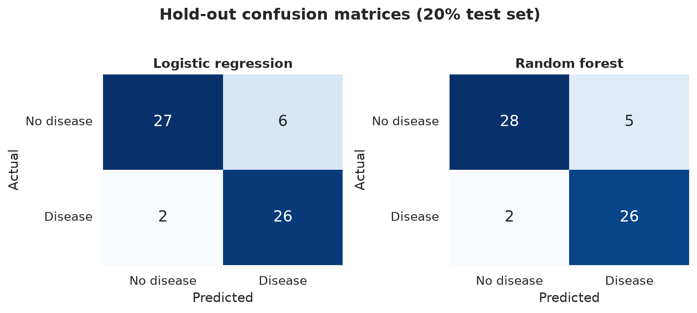
Figure 3. Confusion matrices show missed cases and false alarms. In a screening project, missed cases need special attention, but finding more cases may also create more follow-up work.

7.4 How the model makes patterns visible
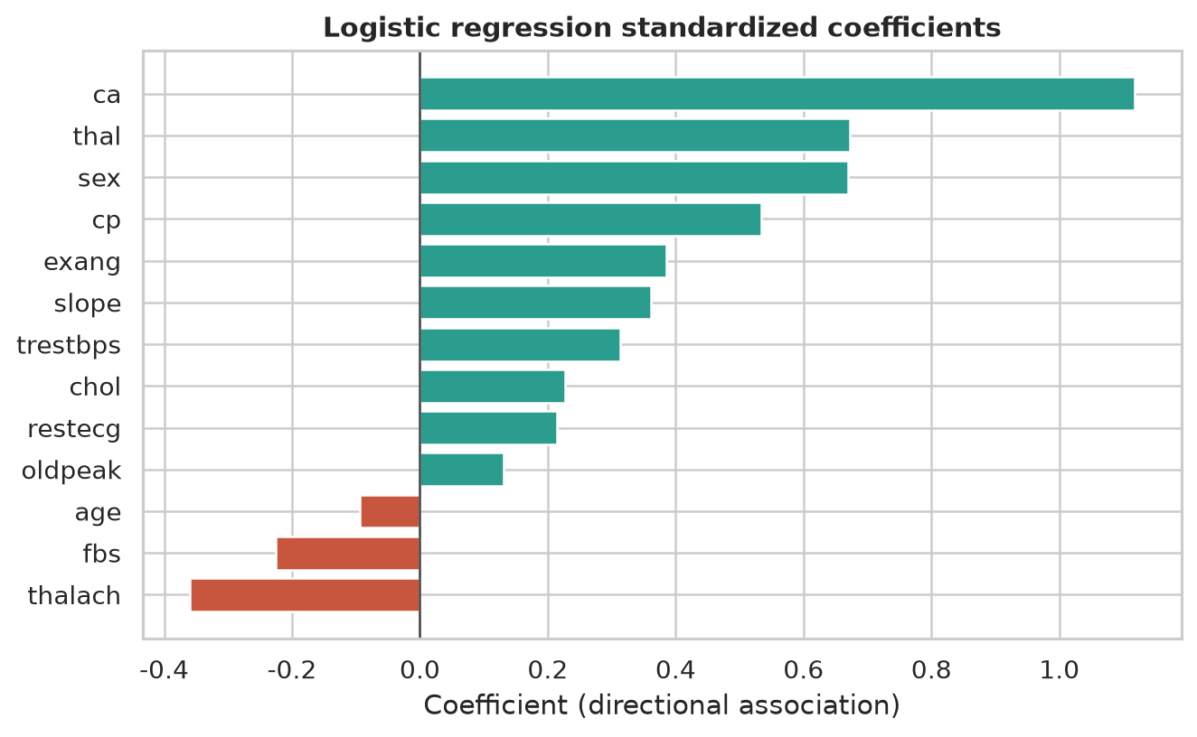
Figure 4. These bars show which inputs are linked with higher or lower model scores. They are model patterns, not proof of cause and not medical advice.

8. Risks and Backup Plans
Risk | Chance / effect | Warning sign | Fix / backup plan
Data leakage | Medium / High | Unexpectedly strong performance or features derived from target. | Keep preprocessing inside a pipeline; review each feature; lock the test set until final evaluation.
Small or unrepresentative sample | High / High | Large metric swings across folds or subgroup instability. | Use repeated validation where feasible; report uncertainty; seek external validation; do not deploy.
High false-negative rate | Medium / High | Recall below the agreed target or concerning missed cases. | Tune threshold for sensitivity; inspect cases; use human review; document residual risk.
Missing or mis-coded values | High / Medium | Parsing errors, unexpected categories, or imputation spikes. | Validate schema; profile missingness; use explicit imputation; add data-quality checks.
Poor calibration | Medium / High | Predicted probabilities do not match observed event rates. | Evaluate calibration curve/Brier score; calibrate with a validation set; avoid presenting raw scores as risk.
Fairness / subgroup performance | Medium / High | Recall or precision differs materially across groups. | Run subgroup metrics; engage governance reviewers; collect better representative data.
Repeatability failure | Medium / Medium | A clean run cannot reproduce figures or metrics. | Pin versions, record seeds, save configuration, and run a clean-environment check.
Inappropriate operational use | Low / Critical | Stakeholder treats output as a diagnosis or autonomous decision. | Use prominent intended-use limits; require governance approval and clinician oversight.

9. Rules, Ethics, and Safe Use
A person should always review the model output, and evidence should come before deployment. The output is a research signal, not a diagnosis. Do not treat model patterns as causes, use untested cutoffs for care, or claim that these benchmark scores prove clinical value. Before using real data, check permissions, privacy, security, clinical review, and the required approval process.
- Record where the data came from, how it may be used, how long it is kept, and who can access it.
- Keep early exploration separate from final testing and record all important changes.
- Report scores for available demographic groups when there are enough records to do so responsibly.
- Have a clear fallback: if the data is poor or the result is uncertain, do not make a prediction and ask for human review.
- After release, watch for data changes, missing values, poor probability scores, group differences, and changes in medical practice.

10. Final Files and Handoff
Deliverable | Contents | Owner / review
Project plan | Goals, users, scope, timeline, risks, metrics, and governance boundaries. | Week 1 / intern
EDA notebook or script | Data loading, schema checks, missingness, distributions, and profile charts. | Week 2 / intern
Modeling pipeline | Leakage-safe preprocessing, logistic regression, random forest, and saved configuration. | Week 3 / intern
Evaluation report | Hold-out and cross-validation metrics, ROC curves, confusion matrices, threshold analysis. | Week 4 / reviewer
Model card | Intended use, data, limitations, ethical considerations, and monitoring plan. | Week 5 / intern + reviewer
Reproduction README | Environment setup, run command, expected artifacts, and troubleshooting notes. | Week 5 / intern

11. Final Recommendation
Continue this project as a limited learning and research prototype. First make the data rules, testing method, and error review clear before trying more complex models. Even if the model meets the goals, the next step should be outside testing and formal review—not deployment. The best result for this internship is a clear, repeatable plan that makes future work safer and easier to measure.

References
[1] UCI Machine Learning Repository, “Heart Disease Data Set.” https://archive.ics.uci.edu/dataset/45/heart+disease
Benchmark note: The scores and charts use the Cleveland subset downloaded from the UCI repository. The data uses a fixed 80/20 split, random seed 42, middle-value filling for missing data, and the model settings described above.

